　DD/MM/YYYY

Neighborhood Association Membership Guide

To those moving into the ○○ Neighborhood Association area,

We hope this letter finds you well.

On behalf of the ○○ Neighborhood Association, we offer our warm welcome to you as you have moved into the ○○ Neighborhood Association area.

We at the ○○ Neighborhood Association are involved in various activities to create a fun and safe place to live. We would be grateful if you would learn about these activities and participate as much as you can.

If you wish to join after reading the attached document, please contact us using the following information.

We look forward to your membership.

◆The neighborhood association you belong to is the ○○ Neighborhood Assocation, Group #○.

◆The Neighborhood Association President is ○○ (Address: ○○, Phone: xxx-xxxx).

◆The membership fee is a monthly (yearly) payment of ○○ yen.

※Please reach out to the Neighborhood Association President if you have any questions or concerns.

Sincerely,

President ○○

○○ Neighborhood Association

***Hello!***

***It’s the*** ○○ ***Neighborhood Association.***

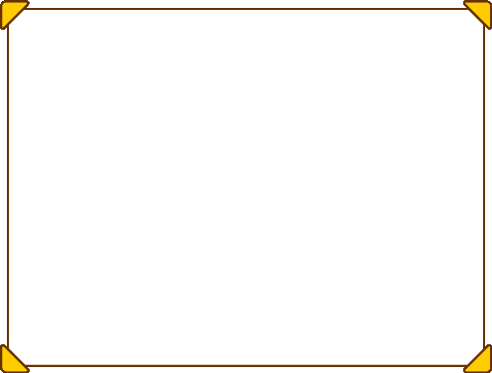

Recently, it has felt that communities are interacting with each other less and less as views and lifestyles diversify. However, there are many aspects of daily life that cannot be resolved alone, such as improving living environments and protecting children and elderly people from increasing crime.

In our neighborhood association, we are involved in various activities to make our community a safe and happy place to live while promoting friendship and interaction with all residents. The monthly membership fee is ○○ yen.

Will you help us make ○○-machi a fun place to live?

For those wishing to join, please submit the attached “Neighborhood Association Membership Application” to either the Neighborhood Association President (○○) or place it in the post box by our neighborhood association’s meeting spot (next to ○○ Park).

We look forward to your participation as a fellow member of our association.

We are involved in the following activities:

**① Friendship Building**　Summer festivals, ground golf tournaments, children meeting activities (mochi making parties, radio gymnastics), etc.

**② Environmental Beautification**　Waste station management, gathering recyclables, etc.

**③ Welfare**　Reaching out to and supporting elderly people who live alone, respect-for-the-aged meetings, etc.

**④ Crime/Disaster Prevention**　Crime prevention patrol, year-end night watch, etc.

**⑤ Revitalization** Requesting administrations to set up roads and other environmental improvements, etc.

【Contact Information】 ○○○ Neighborhood Association, President ○○ ○○

Address: ○○○　　　 E-mail: ○○＠○○○.○○

Phone: ○○○-○○○○　　Fax: ○○○-○○○○